Responsive Product Card Test

Short Note (Easy English)
This product card is responsive. It changes its look based on the screen size.

Mobile (small screens, under 600px):
The card becomes vertical. Image is on top and text is below. Everything is centered. Font size is smaller and padding is less. This makes it easy to read on phones.

Tablet (medium screens, 601px to 900px):
The card becomes horizontal. Image is on the left and details are on the right. Font size is medium. It looks good on tablets.

Desktop (large screens, above 900px):
Still horizontal layout. Font size and padding become larger. The card looks bigger and more spacious on big computer screens.
Overall, the design adapts well so users have a good experience on any device.

1. Mobile View (375px width)
Layout changes to column (image on top, text below). Centered text. Smaller font.

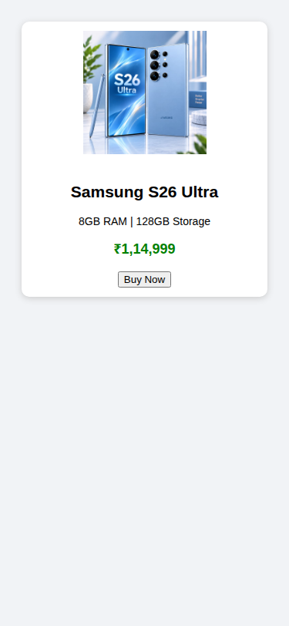

2. Tablet View (768px width)
Side-by-side layout (image left, details right). Medium font size and padding.

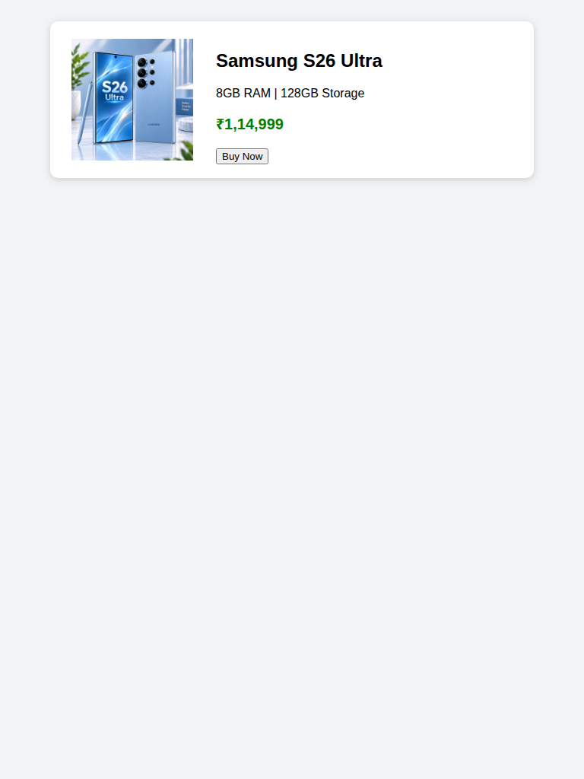

3. Desktop View (1200px width)
Side-by-side layout with larger font and more padding for a spacious look.



